AI STUDY BUDDY API
TEAM ID-SWTID-2026-4215
TEAM SIZE-5
S.VAIDHEESHWARI-TEAM LEADER
S.THIRISHA-TEAM MEMBER
M.KALAISELVI-TEAM MEMBER
D.PREETHI-TEAM MEMBER
S.VAHINA-TEAM MEMBER
Introduction
AI StudyBuddy is an intelligent educational assistant designed to help students learn, revise, and organize their studies effectively. The system uses Artificial Intelligence to provide personalized academic support based on the student’s learning requirements. It can explain difficult topics, answer questions, generate summaries, create study materials, and assist with revision. Unlike traditional study methods, AI StudyBuddy provides interactive and instant assistance, allowing students to learn at their own pace. The project aims to improve learning efficiency, reduce study difficulties, and provide students with an easily accessible digital learning companion.
Problem Statement
Students often face difficulties understanding complex subjects, finding suitable study materials, managing their study time, and preparing for examinations. Traditional learning resources may not provide immediate answers or personalized explanations. Students may also spend considerable time searching for relevant information from different sources. AI StudyBuddy addresses these problems by providing an interactive platform where students can ask questions and receive understandable responses. The system can organize learning content, simplify difficult concepts, and support revision activities. Therefore, the project focuses on developing an AI-based study assistant that makes learning more personalized, accessible, and efficient.
Objectives
The main objective of AI StudyBuddy is to create an intelligent learning assistant that supports students throughout their academic activities. The system aims to provide quick answers to educational questions and explain concepts in simple language. Another objective is to generate useful study resources such as summaries, notes, questions, and revision materials. The project also aims to reduce the time students spend searching for information. Personalization is another important objective, allowing students to receive assistance according to their learning needs. Overall, AI StudyBuddy aims to improve understanding, productivity, revision, and student engagement through Artificial Intelligence.
Existing System
In the existing system, students generally depend on textbooks, classroom teaching, search engines, educational websites, and manually prepared notes. These resources can provide useful information, but they may require students to search through multiple sources to find appropriate explanations. Traditional systems usually do not adapt their responses according to individual learning requirements. Students may also have difficulty identifying important topics during examination preparation. Although online educational platforms provide learning content, many do not offer personalized, conversational assistance. AI StudyBuddy improves upon these limitations by combining educational resources with an AI-based conversational system capable of providing interactive support.
Proposed System
The proposed AI StudyBuddy system provides an intelligent and interactive platform for academic assistance. Students can enter questions or requests through the application, and the AI processes the input to generate relevant responses. The system can support activities such as question answering, topic explanation, summarization, note generation, and revision. Depending on the implementation, it may also provide quizzes and personalized study recommendations. The proposed system is designed to make educational assistance available whenever required. By combining Artificial Intelligence with a user-friendly interface, AI StudyBuddy provides students with a convenient digital environment for independent and personalized learning.
Key Features
AI StudyBuddy contains several features designed to support different stages of learning. The chatbot allows students to ask academic questions and receive AI-generated explanations. A summarization feature can convert lengthy educational content into shorter and easier-to-understand notes. The system can also generate questions or quizzes for examination practice. Topic explanations can be adapted to different levels of understanding, helping students learn complex concepts gradually. Additional features may include study-plan generation, revision assistance, progress tracking, and document-based question answering. These features make AI StudyBuddy a multifunctional educational assistant rather than a simple question-answering application.
System Architecture
The AI StudyBuddy architecture generally consists of four major layers: user interface, application server, AI processing layer, and database. The user interacts with the system through a web or mobile interface. The application server receives the user request and manages communication between different components. The AI processing layer analyzes the request and generates an appropriate response using an AI or Large Language Model. The database can store user information, study history, documents, and other required data. The final response is returned to the user through the interface. This architecture provides a structured and scalable foundation for the project.
Technologies Used
The technologies used in AI StudyBuddy depend on the selected implementation. A frontend framework such as HTML, CSS, JavaScript, React, or Flutter can be used to develop the user interface. Python, Java, Node.js, or another programming language can be used for backend development. AI functionality can be implemented using an appropriate Large Language Model or AI API. Databases such as MySQL, PostgreSQL, MongoDB, or Firebase can store application data. Additional technologies may include authentication systems, document-processing libraries, and cloud hosting platforms. These technologies work together to provide an interactive, reliable, and intelligent educational application.
AI Module
The AI module is the central component of AI StudyBuddy. It processes student questions and generates meaningful educational responses. Natural Language Processing techniques allow the system to understand the meaning and context of user inputs. A Large Language Model can then generate explanations, summaries, examples, questions, and other study materials. Prompt design can be used to control the response style, difficulty level, and educational format. If document-based learning is implemented, retrieval techniques can provide relevant information from uploaded materials before generating an answer. The AI module therefore enables the system to deliver interactive and personalized academic assistance.
Database
The database is responsible for storing and managing information required by AI StudyBuddy. Depending on project requirements, it may contain student profiles, login information, study history, uploaded documents, generated notes, quiz results, and learning preferences. A relational database can organize information using structured tables, while a NoSQL database can provide flexible storage for different types of data. Proper database design is important for maintaining consistency, security, and efficient data retrieval. The system should also apply appropriate authentication and access controls so that users can access only their authorized information. Database management therefore supports both personalization and reliable system operation.
User Interface
The user interface provides the interaction between students and AI StudyBuddy. It should be simple, clear, responsive, and easy to navigate. Important components may include a login page, dashboard, AI chat screen, study-material section, quiz interface, and profile page. The chatbot interface allows students to enter questions and view AI-generated answers. Buttons and navigation menus should clearly identify available functions. A responsive design allows the application to work effectively on computers, tablets, and smartphones. A well-designed interface improves usability and helps students focus on learning rather than dealing with complicated application controls.
Working Process
The working process begins when a student logs into AI StudyBuddy and selects a required learning function. The student enters a question, uploads material, or requests a specific study resource. The application sends the input to the backend, where it is processed and forwarded to the AI module. The AI analyzes the request and generates a suitable response. If relevant documents or stored information are available, they can be considered during processing. The generated result is then returned to the application and displayed to the student. The interaction can continue conversationally, allowing students to ask follow-up questions and clarify concepts.
Advantages
AI StudyBuddy provides several benefits for students. It offers immediate academic assistance without requiring students to wait for external support. Complex topics can be explained in simpler language, helping students understand difficult concepts. The system can generate personalized study materials and revision questions, reducing preparation time. Students can also interact with the AI repeatedly and ask follow-up questions whenever clarification is required. Since the system can be accessed digitally, learning support can be available from different locations and at different times. These capabilities can complement classroom teaching and encourage students to practice self-directed and continuous learning.
Limitations
Although AI StudyBuddy can provide useful educational assistance, it has certain limitations. AI-generated responses may occasionally contain incorrect, incomplete, or outdated information. Therefore, students should verify important academic information using reliable textbooks, teachers, or authoritative sources. The quality of responses can also depend on how clearly users formulate their questions. AI systems may not always understand highly specialized or ambiguous queries correctly. Internet connectivity may be required if the application depends on cloud-based AI services. Privacy and security are also important considerations when storing student information or uploaded documents. These limitations should be addressed through appropriate system design and responsible usage.
Future Enhancements
AI StudyBuddy can be expanded with several advanced features in the future. A voice-based assistant could allow students to interact using speech. Multilingual support could make the platform accessible to students who prefer different languages. Computer vision could enable the system to analyze handwritten notes, diagrams, or textbook images. Advanced personalization could create study schedules based on student performance and learning patterns. Integration with educational platforms could provide additional learning resources. The system could also include stronger document retrieval, progress analytics, gamification, and adaptive quizzes. These improvements could make AI StudyBuddy a more comprehensive and personalized educational platform.
Conclusion
AI StudyBuddy is an AI-powered educational assistant designed to make learning more interactive, accessible, and personalized. The project combines Artificial Intelligence, natural language processing, databases, and a user-friendly interface to provide academic assistance. Students can use the system to understand concepts, ask questions, create summaries, and practice through generated learning materials. Although AI responses should be verified for accuracy, the system can serve as a useful supplement to traditional education. The project demonstrates how Artificial Intelligence can be applied to solve common learning challenges
and provide students with a digital study companion for continuous academic support.

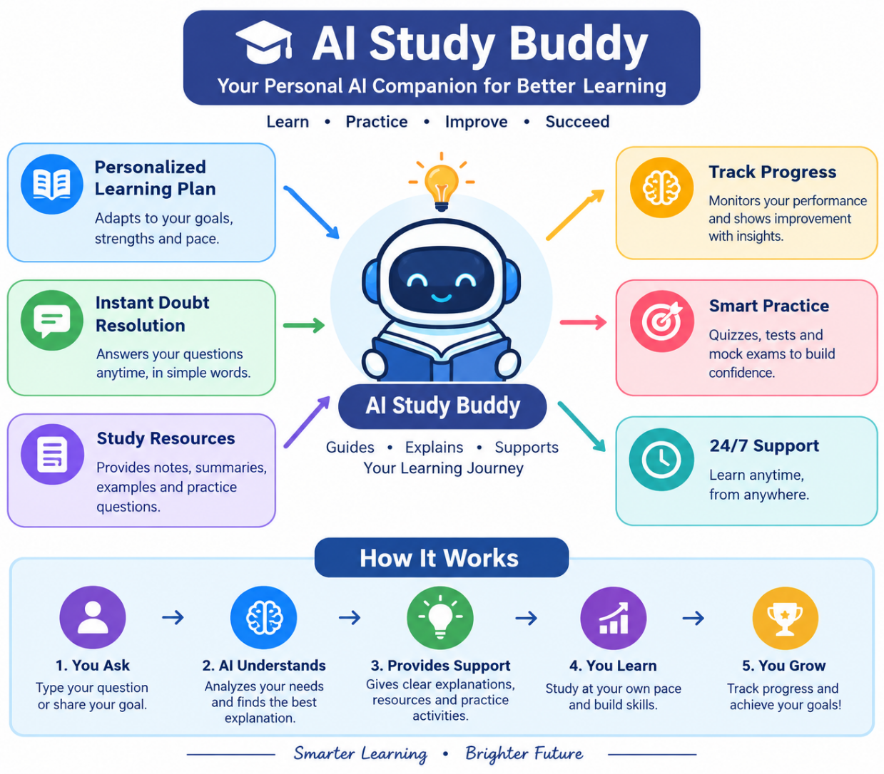

THANK YOU

